Titan Haze Paper
cihat kurt

The Final Report
I searched for the best-fitting phase functions among nearly$5×{10}^{5}$model runs using an automated algorithm. The algorithm determines different constraints for each altitude and finds two parameter ranges for each wavelength channel (one for each altitude). It obtains the constraints from the maximum polarization, the phase function at the forward scattering angles and the single scattering albedo (SSA or $ω_{0}$) by comparing the model aggregates to the observations. Then based on the mean square error (MSE) the algorithm decides whether a model aggregate fits to the observations. As for the values of the phase functions at backscattering angles ($ν≥75$), the code checks the MSE and makes two sample Anderson-Darling (AD) test to compare the curves of phase functions at these angles. Then based on the MSE and the p-values of the AD test the model aggregates are either decided to match the DISR phase function or not. AD test provides a quantitative measure for how much the shapes of the phase functions being compared resemble each other as well as how close the individual points on the curves in average.
Even though I adopted a single phase function throughout the atmosphere for each channel, SSA observations provide constraints on the refractive index at two altitudes . Therefore, for each layer, a unique parameter ranges can be found by simply selecting the model aggregates which agree with all three observations (SSA, phase function, linear polarization). Besides, the phase function also constraints the refractive index.
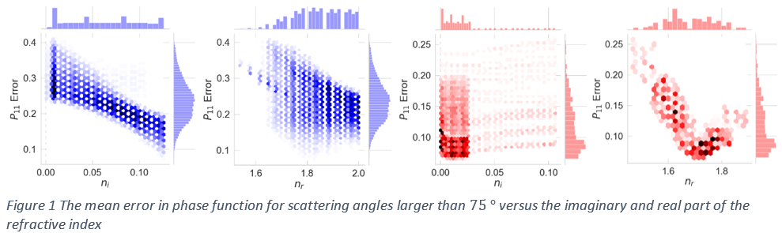
As shown in Figure x , Figure y and Figure zwhile $n_{r}$ is mostly constrained by the phase function, $n_{i}$is constrained mostly by SSA except that the phase function in the blue channel also strongly correlated with $n_{i}$, suggesting strong absorption.
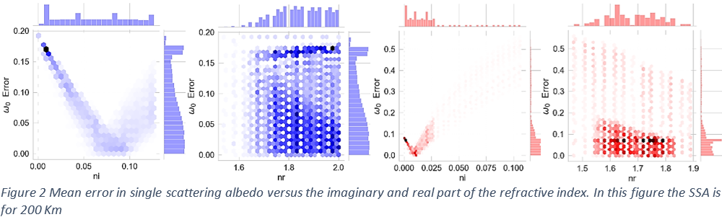
The constraints on the refractive index from the phase functions agree with the constraints from SSA except that blue-phase function suggests larger $n_{i}$ than the SSA measurement does in the blue channel 80 km altitude. The algorithm finds almost no model that passes all the filters at 80 km in the Blue channel without allowing at least 10% error in SSA or more than 20% error in the phase function at the backscattering angles. This could be due to the error in SSA observation or the blue phase function at this level given in the DISR model. In the DISR model, both in the original (Tomasko et al., 2008) and revised version (Doose et al., 2016), blue phase function is constant throughout the atmosphere while the SSA is changing. It has been suggested by Tomasko et al. (2008) and Doose et al. (2016) that some condensation at the aerosol surface occurs in the lower atmosphere resulting in a decrease in absorption while keeping the phase function relatively constant.
On the other hand, the fact that our model does not produce any aerosol matching all the constraints within 5% accuracy might suggest that constant phase functions throughout the atmosphere might not be an accurate representation of reality. Likewise, the SSA measurements at 80 km strongly suggest that the $n_{i}$ values are considerably smaller (Figure xx) than what the phase function suggests in the blue channel (Figure 1 ). Perhaps, the condensing particles on the aggregate’s surface not only change the $w_{0}$ but also the phase function of the haze particles. (Give an example from brown and black carbon, freshly produced and aged one). However, It is still possible that the new parameterization might also be the source of this apparent disagreement, or the SSA measurement may not be accurate at 80 km in the blue channel.
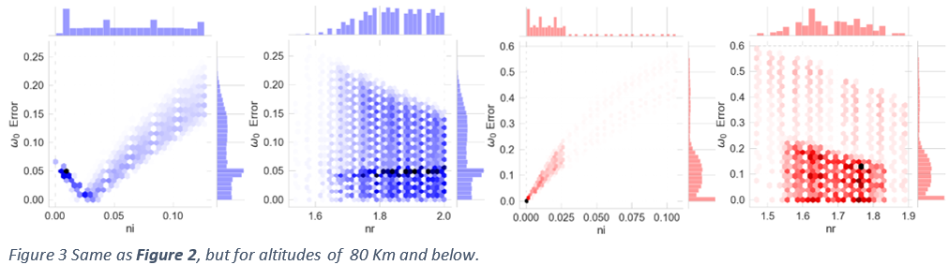
Due to this disagreement between the constraints from the phase function and the SSA measurements in the blue channel, at 80 Km altitude, I applied a slightly different method to determine the constraints for this particular case. In this method, the algorithm first finds the monomer number and the size ranges from the DISR phase functions and the maximum polarization without yet comparing the$w_{0}$ values. Next, inside the aggregate size range ($N and R_{m}$) it determines the range of refractive index from the $ω_{0}$measurements within the 5% error limit. As a result, the constraints from $ω_{0}$ is semi-independent from the backscattering values of the phase function but not from the values of the forward angles of the phase function and the maximum polarization, which are still set to fit within 5% limit as they are the only direct measurements apart from $ω_{0}$.
Table 1 and figure 2 & 3 summarizes the parameters of the haze particles. Constraints from the same channel provide the same parameter range at each altitude except for the imaginary part of the refractive index. This is consistent with the observation as the SSA measurements imply that more absorbing particles are found at higher altitudes while the size of the aggregates is somewhat constant.
Monomer size ranges found from each channel are consistent and about the same at each altitude. On the other hand, at a given altitude, the ranges of monomer number ($N$) differ depending on which channel they are calculated from. As seen in Figure x and Figure y , the range of monomer numbers in aggregates that fits the observations is shifted upward in the Red channel comparing to those obtained in the blue channel. The similar inconsistency between each channel also appears in the overall size of the haze model particles ($R_{agg}),$ especially for the 80 km altitude.
Altitude | Channel | $N$ | $R_{m}$ | $R_{agg}$ | $n_{r}^{*}$ | $n_{i}^{*}$
200 km | Red | $2950−4700$ | $0.036−0.045$ | $0.61−0.65$ | $1.62−1.83$ | $0.004−0.022$
 | Blue | $2200−3450$ | $0.038−0.049$ | $0.56−0.65$ | $1.77−2.0$ | $0.096−0.126$
80 | Red | $2950−4700$ | $0.036−0.045$ | $0.61−0.65$ | $1.62−1.83$ | $0.0005−0.008$
 | Blue | $2200−3450$ | $0.036−0.048$ | $0.55−0.62$ | $1.79−2.0$ | $0.01−0.066$
Table 1 shows the results from all the constraints at each layer and each channel. These results obtained by finding the model-aerosols within 5% accuracy to all the observations (Phase function, maximum polarization, SSA) except at the backscattering an
Ghfh
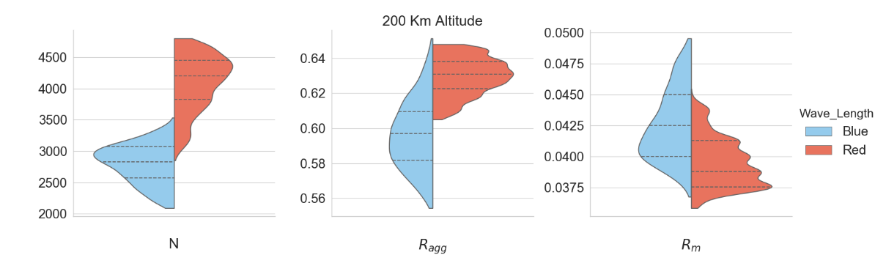
Figure 4
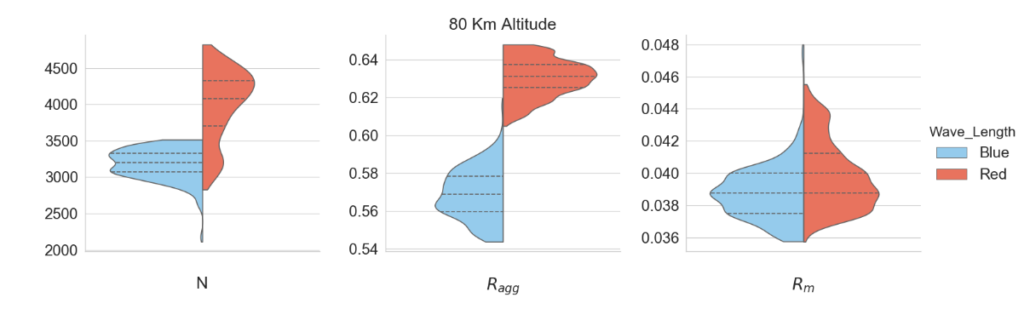
Figure 5
Table 2 shows the parameters of the haze particle obtained by combining the constraints from both channels except for the refractive index. Two different parameter ranges are calculated for each altitude. One from combining only the intersection of the parameter ranges of the blue and red channel and another is the union of two sets from each channel, labeled as Inner and Outer, respectively, inTable 2 .
Therefore, if we neglect the model aggregates which do not agree with the constraints from both channels (Inner combination), then we find that the haze particles have about $3200±250$monomers each have a radius of $R_{m}=0.042±0.004$. Otherwise accounting all the model aggregates which agree with the constraints from at least one channel (outer combination) suggest that the haze particles have about$N=3400±1300$ monomers with monomer radius$R_{m}=0.042±0.007$.
Combination | Altitude | N | $R_{m}$ | $R_{agg}$
Inner | 200 km | $2950≤N≤ 3450$ | $0.038≤R_{m}≤ 0.045$ | $0.61≤R_{agg}≤0.65$
 | 80 km | $2950≤N≤ 3450$ | $0.036≤R_{m}≤ 0.045$ | $0.61≤R_{agg}≤0.62$
Outer | 200 km | $2200≤N≤ 4700$ | $0.036≤R_{m}≤ 0.049$ | $0.56≤R_{agg}≤0.65$
 | 80 km | $2200≤N≤ 4700$ | $0.036≤R_{m}≤ 0.048$ | $0.55≤R_{agg}≤0.65$
Table 2 Parameter of Haze related to its size from the combination of constraints in the SA channels. Inner means the parameter ranges combined by the intersection of each channel’s parameter ranges. The outer refers to the combination by the outer edges.
Figure 5 shows the collection of all the fitting phase functions of the model aggregates within the parameter range given in table 1. All the phase functions that make up the table 2 aggregates have an excellent agreement with the DISR model at all scattering angles for the Red phase function except near the backscattering peak. As for the blue phase functions, there is an apparent bias in the intermediate angles. Perhaps the new parameterization does not extrapolate well at these angles and, therefore, cause such a bias. On the other hand, considering that the DISR phase functions were obtained from the old parameterization model (Tomasko et al., 2008), It is also possible that DISR blue phase function may not be accurate at the intermediate angles, albeit they were also constrained by radiative transfer model to fit the observations. Regardless, the algorithm did not use these intermediate angles in the search for best-fitting parameters.
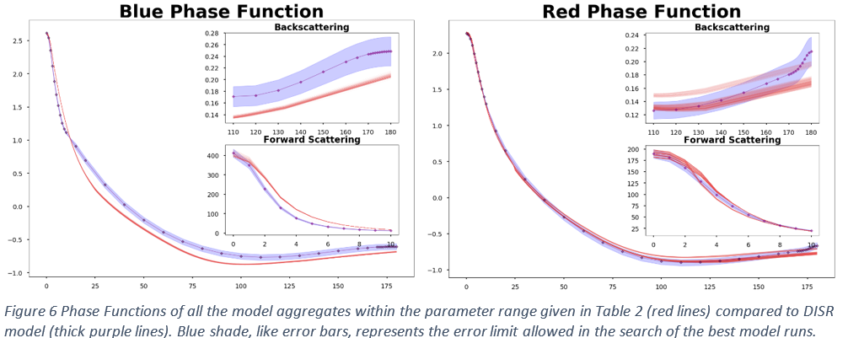
Among the model runs shown in table 1 and fig 3 the best aggregate which fits the DISR phase functions, maximum polarization and SSA measurements (above 80km) within %5 error limit has$∼3.3×{10}^{3}$ monomers with $R_{m}∼ 0.04$. As shown in fig below, such an aggregate fits the DISR phase functions very well in both channels.
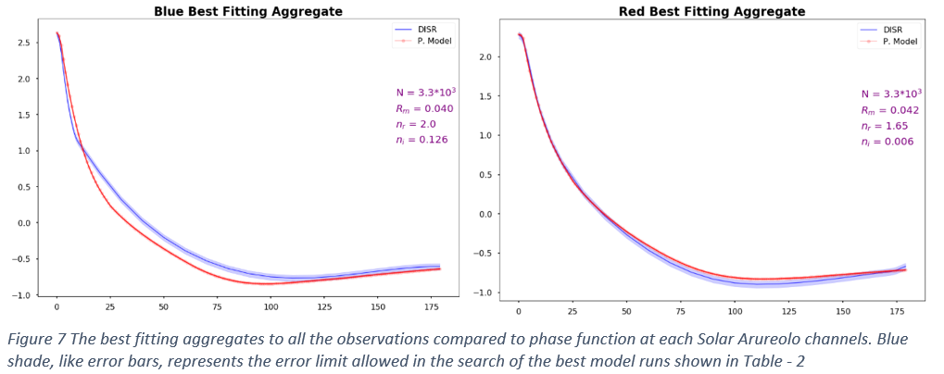
Similarly, When the model aggregates are compared to DISR phase functions at each wavelength independently, the best-fitting phase function at each wavelength agrees better with the DISR phase function at the corresponding channel. However, there is a somewhat 20% difference in the size of the aggregates constrained by each channel.Figure 9 shows the phase functions of these model aggregates in comparison to the DISR model.
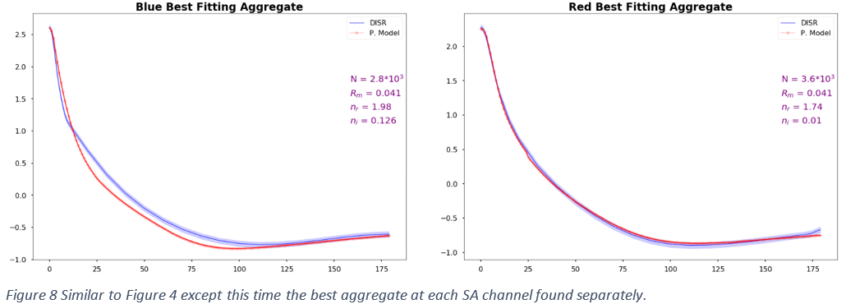
Table 3 compares the parameters
nge between 1500 – 6000.
 | N | $R_{m} (μm)$ | $R_{agg} (μm)$
This Work | $$3300$$  $$2200≤N≤ 4700$$ | $$0.041$$  $$0.038≤R_{m}≤ 0.045$$ | $$0.63$$  $$0.61≤R_{agg}≤0.65$$
Tomasko et al. (2008) | $$3000$$  $$1500≤N≤ 6000$$ | $$0.05$$  $$0.03≤R_{m}≤0.07$$ | $$0.72$$
Tomasko et al. (2009) | $$4300$$  $$3000≤N≤7000$$ | $$0.04$$  $$0.03≤R_{m}≤0.05$$ | $$0.65$$  $0.57≤R_{agg}≤0.72$ *
Other
Table 3 Comparison of the Titan’s haze parameters estimated by different studies. The best estimate given in each work is shown as bold text. The range of the parameter estimates is given if available. * Aggregate size is not given explicitly in the reference text but calculated based on given monomer size uncertainty and the corresponding monomer numbers estimate.
( From Tomasko 2009: “Different authors have found the monomer size of Titan’s haze aerosols to be due to different effects. Cabane et al. (1992) and Ran- nou et al. (2000) found that the monomer size depended most on the altitude of formation of the aggregate particles. In their models, larger monomers could be supported at lower altitudes, and this determined the monomer size of the aggregate aerosols. In a new study, Rodin et al. (2009) used a different way of estimating the electrical charge on the aerosol particles. They find that monomers smaller than about 0.05 lm”)
Because of the possibility of some condensation on the surface of the haze particles below 80 km, which in turn reduces $n_{i}$, here I only compare the refractive index constrained by the measurements at 200-km altitude to the laboratory studies. The ranges of refractive index at 491 nm and 935 nm wavelength obtained in this work are closer to the ones obtained by Khare et al. (1984) than the other laboratory studies shown in Figure 7 . At 491 nm $n_{r}$ is found to be in between 1.77 – 2.0 and $n_{i}$ is in between 0.-096 – 0.126 while Khare et al. (1984) found that $n_{r}$= XXX and $n_{i}$=YYY . At 935 nm in this work $n_{r}$is between 1.62 – 1.83 and$n_{i}$ ranges from 0.004 to 0.022 whereas Khare et al. (1984) found that $n_{r}=xx$ and $n_{i}=yy$.
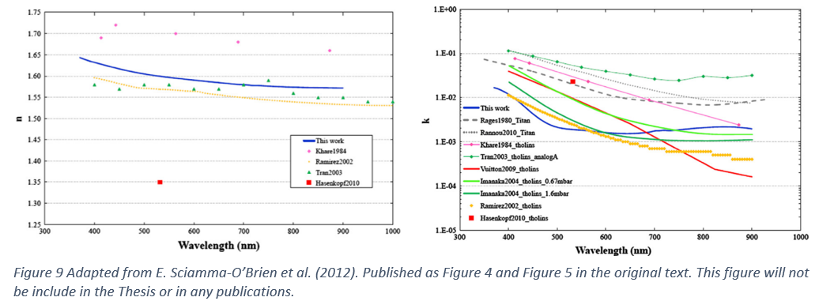

Conclusion
DISR model for Titan’s haze was published in (Tomasko et al., 2008). The model includes phase functions for several wavelengths, but the ones for 491 nm and 935 nm are the focus of this work because these are the peak wavelengths that were detected by the Solar Aureole camera, which directly measured the forward scattering of solar radiation. Doose et al. (2016) revised the phase functions and the single scattering albedo measurements based on more detailed analyses of measurements inside and outside of the Titan’s atmosphere. As opposed to the original DISR model (Tomasko et al., 2008), they used a single phase function throughout the atmosphere for each wavelength. I adopted the DISR model phase functions and SSA from Doose et al. (2016). As for the linear polarization, Tomasko et al., (2009) analyzed the polarization data in more detail than Tomasko et al., 2008 did. I, therefore, utilize the polarization data given by Tomasko et al., (2009) in this work.
Since the DISR measurements are analyzed in blue and red channels, for each altitude, two sets of constraints on the parameters of haze are obtained. While the constraints on the refractive index are unique to each wavelength, the monomer number and monomer size are supposed to be the same no matter which channel’s data is used to constraint them. Unfortunately, there is some discrepancy between the ranges of N obtained from each channel (see table 1 figure 2 and figure 3 ). For this reason, the combination of the constraints from both channels results in more extensive parameter ranges than the ones obtained by each channel, unless only the intersections of the parameter ranges are considered to match the measurements (see Table 2 ). In any case , the parameter ranges are in line with, but narrower than, the ones obtained by earlier works (see Table 3)
Based on all the constraints from DISR measurements, the best fitting aggregates contain 2900-3500 monomers with monomer size, $R_{m}$ is between 0.038 – 0.045. The aggregates with larger N have usually smaller $R_{m}$ or vice versa. Hence, the range of the overall size of the aggregates which fits the observations is narrower:$0.61≤R_{agg}≤0.63$, where $R_{agg}$ is the radius of an equivalent volume sphere. Comparing to (Tomasko et al., 2008) all the parameter ranges found in this work are narrower. Even without combining the constraints from Blue and Red channels but selecting a range with a minimum and maximum of both channels gives a narrower monomer number range (see Figure 3) than 1500 - 6000 which was the estimate by Tomasko et al. (2008). In this case, the smallest aggregate has 2200 (from Blue Channel), the largest aggregate has 4700 (Red channel) monomers (see table 2) with monomer size range between 0.038 (Red and Blue channel minimum) and 0.048 (Red channel maximum).
The refractive index ranges are shown in table 2.

